

iT uNIT 19.2

By Adam Chu



Contents

**No table of contents entries found.**

# Diagram of Where Memory is kept on a Motherboard

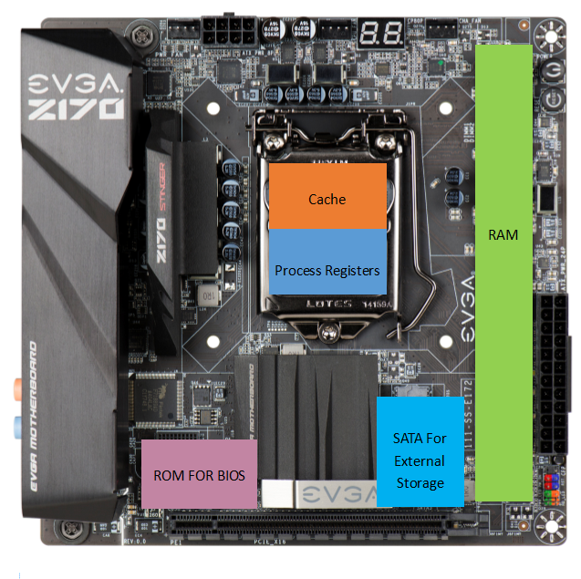

|  |  |  |  |  |  |
| --- | --- | --- | --- | --- | --- |
| Storage Type | Capacity | Speed | Portability | Durability | Cost |
| RAM | <1GB to 128GB (Per Stick) | DDR 333 to DDR4 4700 | Not Very dimensions are small but seeing how they mount to the MOBO (but RAM is modular) | RAM being made out of flash chips means that it is safe from magnets and has better drop resistance than HDD’s | Average £70 |
| ROM | 4 MB or 8 MB per chip | 15 MB/s | ROM is motherboard mounted so it has to stay to the computer | ROM uses flash chips so it is drop proof but the damage could affect other components on the MOBO | Inc With a Motherboard |
| Cache | **This is for a Ryzen 2600****L1 CACHE** 6 x 64 kB Instruction 6 x 32 kB Data **L2 CACHE** 6 x 512 kB **L3 CACHE** 1 x 15.990 MB | The cache is CPU dependent as the Cache is directly used in the Fetch, Decode, Execute & Store  But a 2014 Xeon (server) CPU had a cache speed of Approx. 4000 GB/s | Cache is inside the CPU so it’s quite portable as a CPU is smaller than a RAM stick or a Motherboard | If the CPU or Cache is damaged then the Cache becomes unusable as they are linked. | Inc With CPUs  £100 to £400 (for an average CPU) |
| Process Registers | 1 Instruction | Almost Instant Read and Write Speed | Its inside the CPU | They are linked to the CPU so if the CPU is damaged or the Socket is damaged then it could be unstable | “ |
| SSD (Non-Volatile Flash) | 32GB to 2TB | Sequential Read 3.5Gb/s  Write 2.1 Gb/s | Very portable as you can get enclosures to mount them as USB sticks or Portable storage devices | They use Flash Chips so they are resistant to drops and magnetic interference as well as high motions | £40 to £700  £25 = 120GB |
| HDD | 100GB to 6TB Average 1TB | Random Read / Write speed is 7200RPM usually these are approximately 80-160 MB/s for R&W operations | These are fairly portable due to the smaller 2.5” vairants used inside laptops and portable hard drives. But the larger 3.5” usually require external power (SATA Power). | But they are more prone to damage than a SSD as they have delicate magnetic fields and moving parts which can be damaged | £40 = 1TB of 7200 RPM |

# What does each form of memory do inside a system?

Direct Memory Addressing

This allows the computer to use polling and interrupts to allow memory read and write operations to run intandem with other operatons like logic calculations, what it would normally do is that it would read the entire contents of the RAM needed for that operation then it would do then complete the process.

With DMA it would start the memory read operation then start doing the other processes in the background whilst the memory is being read. Then the system receives an interrupt from the RAM saying DMA has been completed. This is useful for when the normal I/O controller (chipset) is not performing at the same speed so the normal Fetch, Decode, Execute & Store cannot work otherwise the CPU would just stop whilst waiting.

DMA is also used for intra-chip data transfer so for multicore processors and allows full multi-tasking as one core can use DMA and the rest can do other processes as well to get all cores working at once.

## RAM

Ram is used to store the open or active files on ones computer this is used to speed up files as RAM acts in a magnitude faster than normal SSD or HDD. RAM is volatile and this means it is wiped at when a PC powers down. This is used in the Fetch Excetue Cycle as the computer has to move files from the HDD to the Ram and then to the Cache for open files.

## ROM

ROM is used to launch a PC what it has is a version of the UEFI BIOS, which starts up the I/O controller sets the clock speeds for the CPU and RAM. And then loads the OS which then takes over with the initial boot of the computer. But ROM means Read Only Memory so ROM is becoming less valued as UEFI replaced BIOS with constant updates and revisions. So usually the UEFI is stored on Non-Volitile Flash Chips.

## Cache

Cache is a small amount of Flash Storage inside of a CPU, this allows the computer to store a part of a program. Usually this the part of the program going to acted on next this is even faster than RAM as it does not use the motherboard or I/O controller.

## Virtual Memory

Virtual Memory is where the computer runs out of native RAM so it uses a secondary storage for files that are being acted on, but this is not as fast as the actual storage because it is using SATA or NVMe Drives instead of RAM which is a very fast form of flash storage.

## Polling and inturpts

With periperals the use of polling and inturputs allows the computer to check if a device is working at full capacity, by asking a question and then waiting a set amount of time before checking again otherwise all processes would stop until the poll ended.

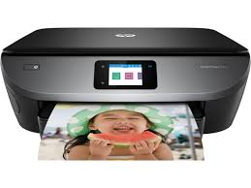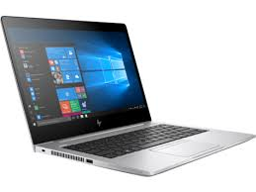

1. The computer asks a question based on does it have enough paper or ink?
2. The computer then pauses this query for a set time
3. The printer responds to this question with a yes or a no to respond to this
4. Then the computer sends another query

The same could said for monitors where the computer sends a signal to a monitor which then asks a query like picture received or is the refresh rate correct. Then the computer asks if the signal was correct then it sends another query. But to make sure the display is not constantly responding to the question it sets a interrupt based on a time limit.

